Prepare the CSV files to import
Make sure that the data to be imported is a CSV file. If it is an XLSX file, convert it first to CSV.
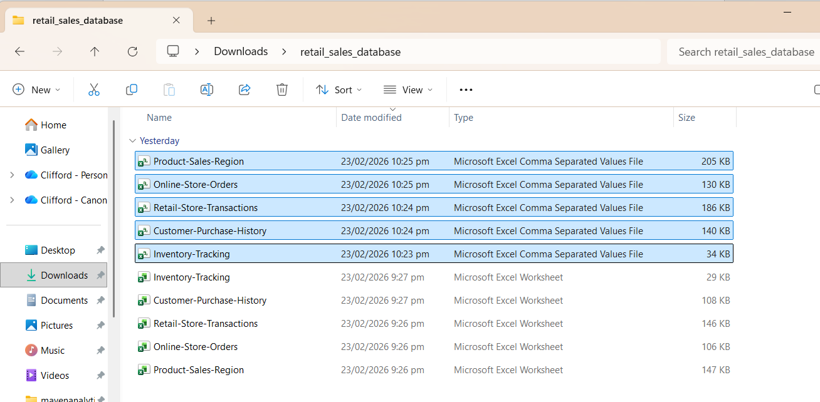

Create new schema in MySQL
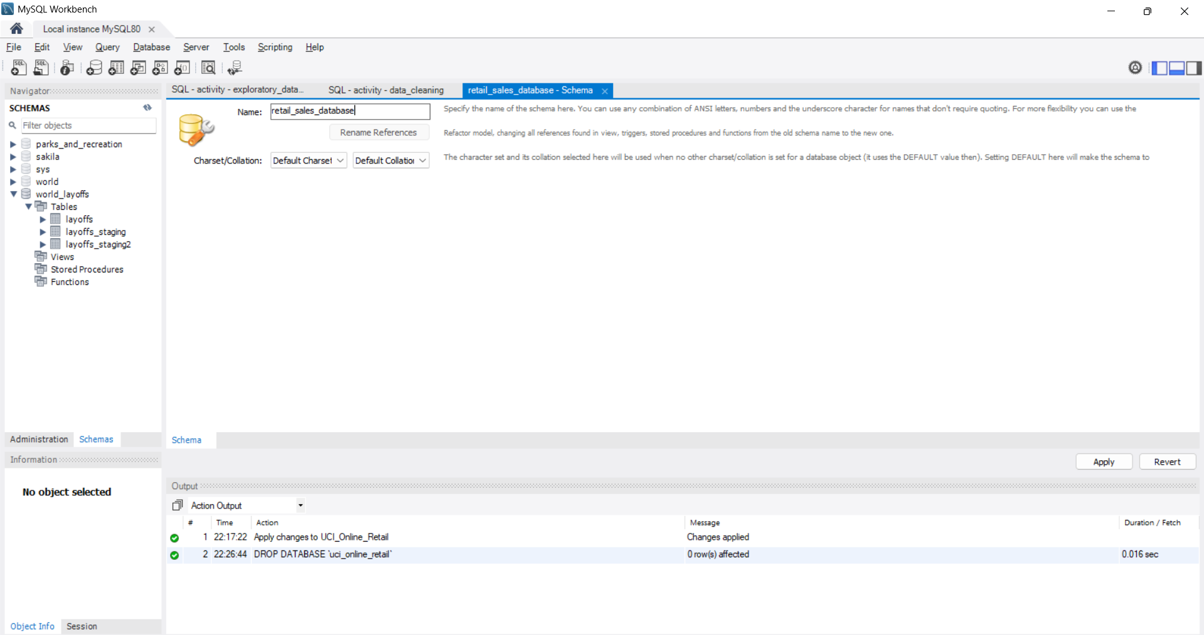

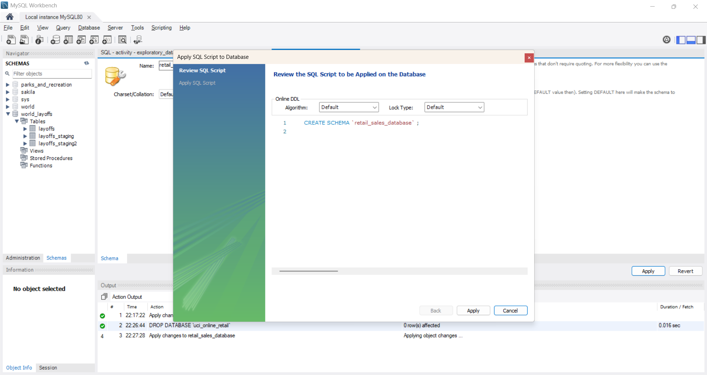

For convenience and for this project, I set the newly created schema as default schema
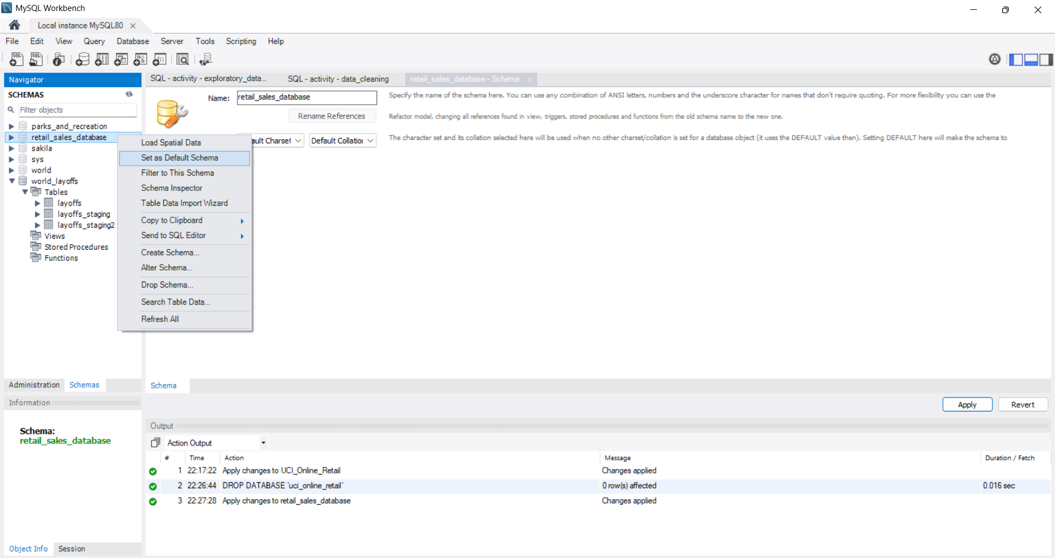

Import CSV file as a data table
Select Table data import wizard
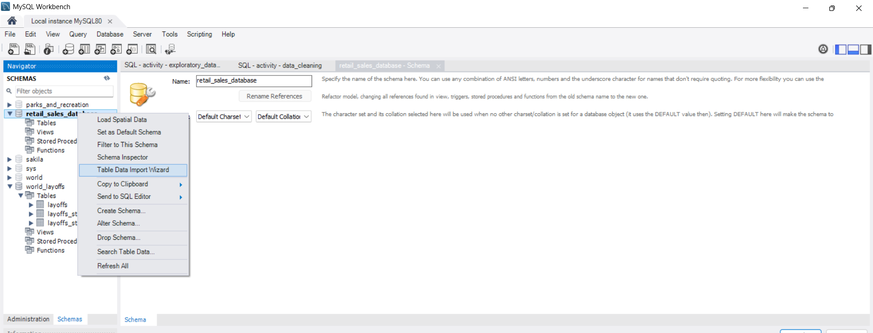

Locate the CSV file. In this example, ‘Product-Sales-Region.csv’ is selected
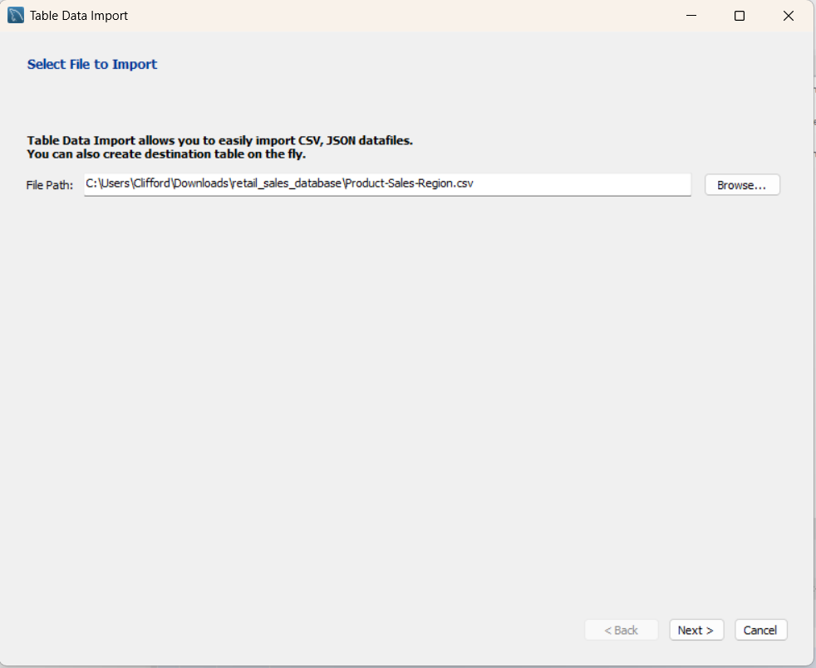

Select ‘Create new table’ and name the table as intended.
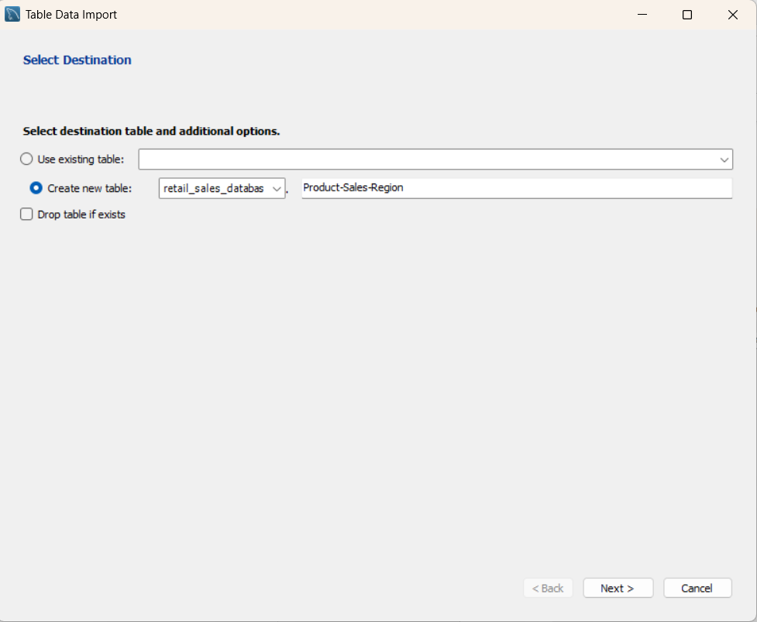

Next will determine the data type. Edit the data type as intended.
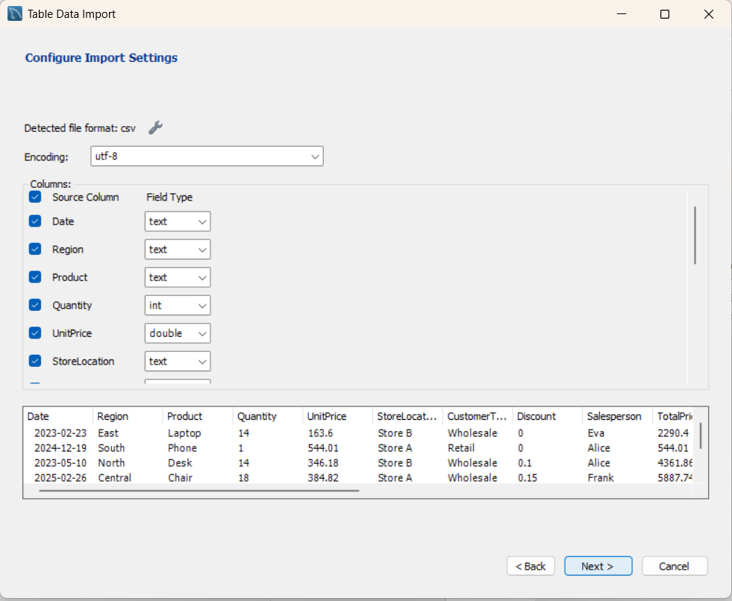

After clicking next you will see a message on the data imported.
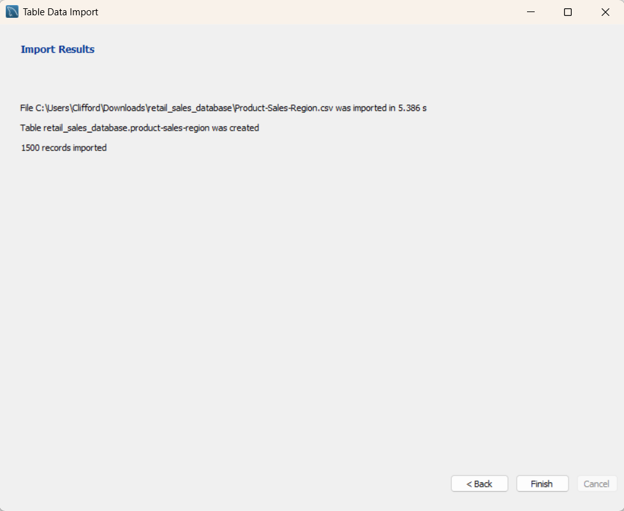

Proceed with importing the rest of the table
